***Autowired Annotation:***

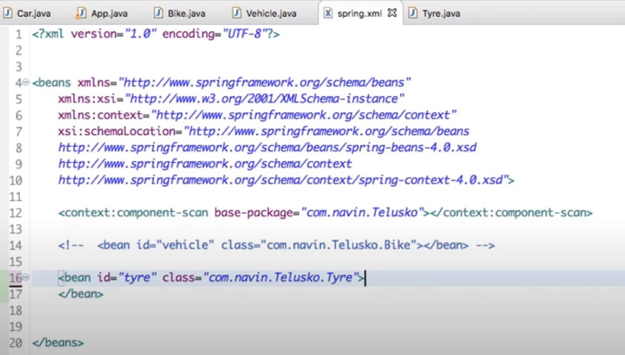

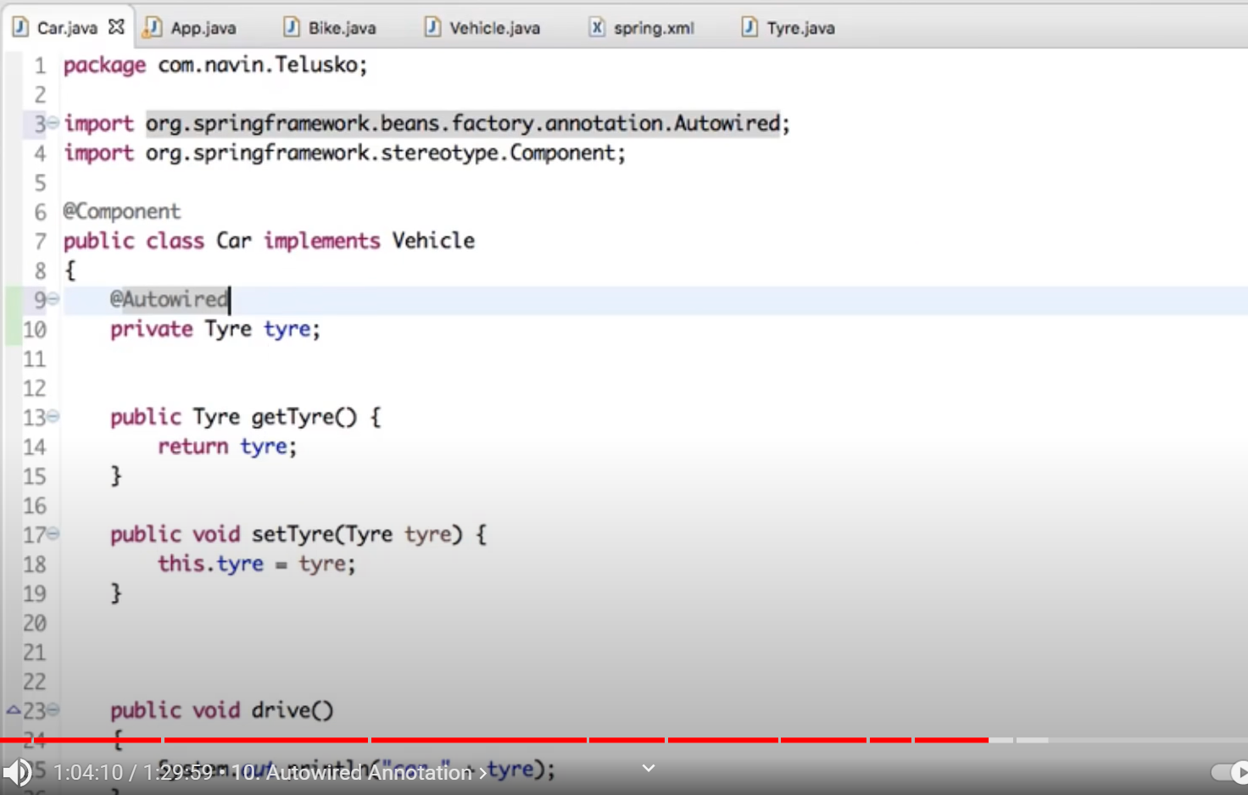

Here @Autowired is required else it would print null when we call car.drive()

Else we can set it in the xml (as we did earlier)

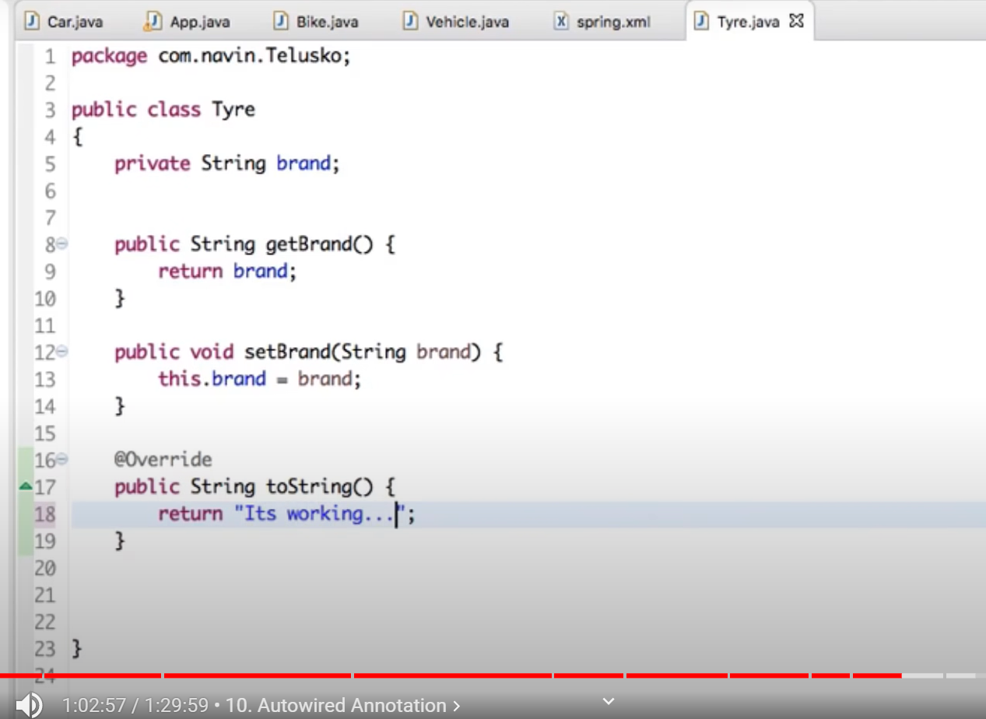

We are using Annotation configuration for Car but xml based configuration for tyre- this is possible.

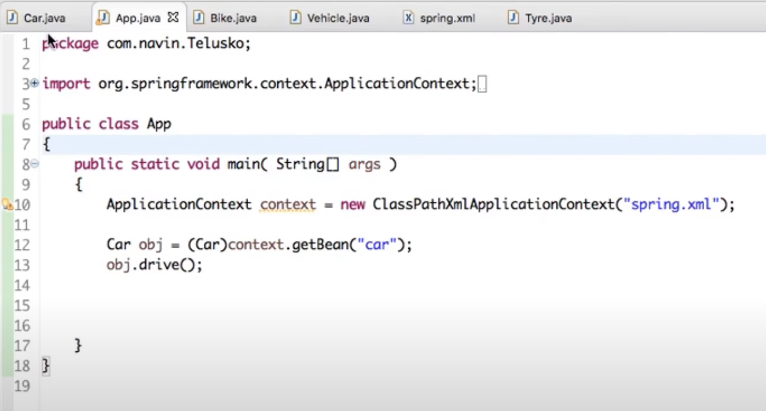

When we run App.java - > It would print: Car Its working…

PART2:

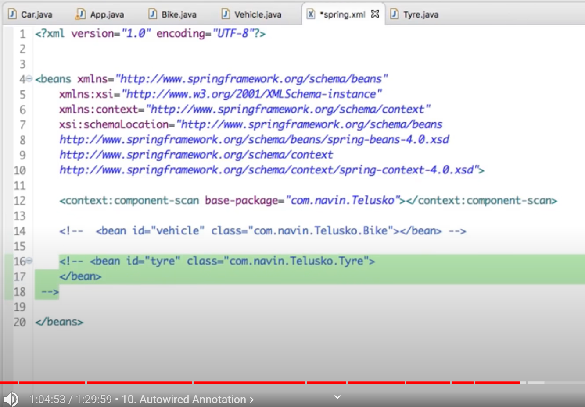

Just comment all the xml configuration

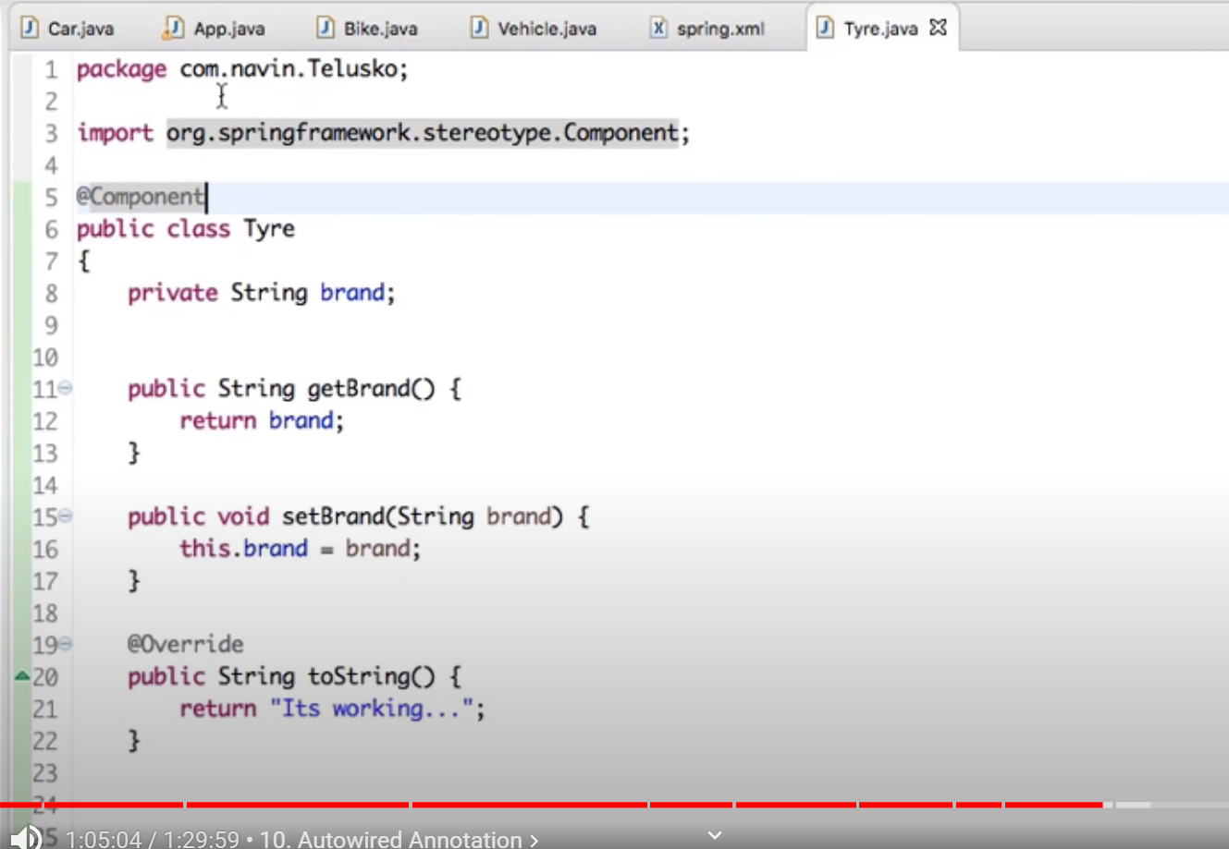

We would need to use @Component in the Tyre as well since we removed it from the xml config file.



When we run App.java - > It would print: Car Its working…

***Application context:***

<https://java-journal.blogspot.com/2012/08/what-is-applicationcontext-what-are-its.html>

***AnnotationBased Example:***

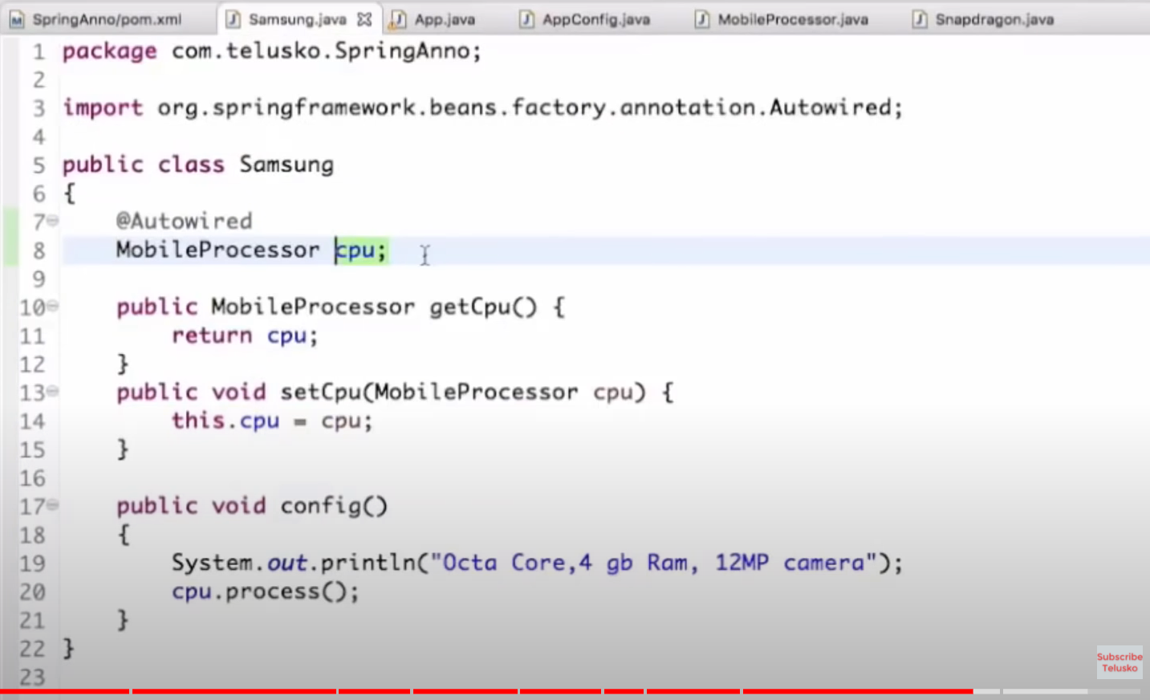

Here @Autowired would get from AppConfig=>@Bean MobileProcessor=>Snapdragon

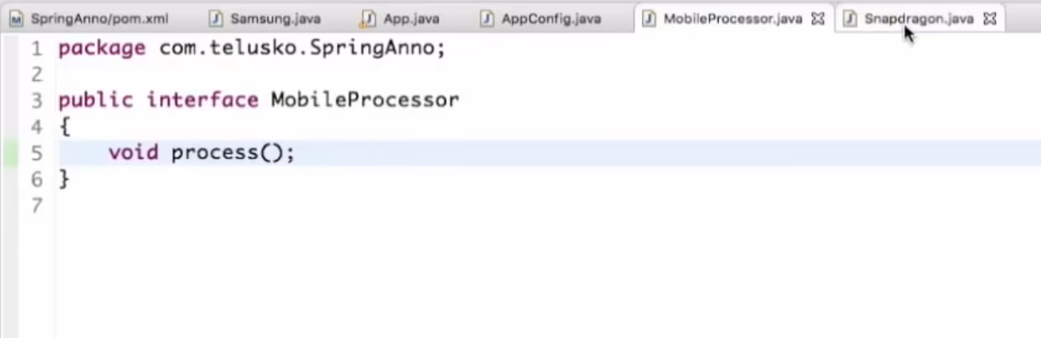

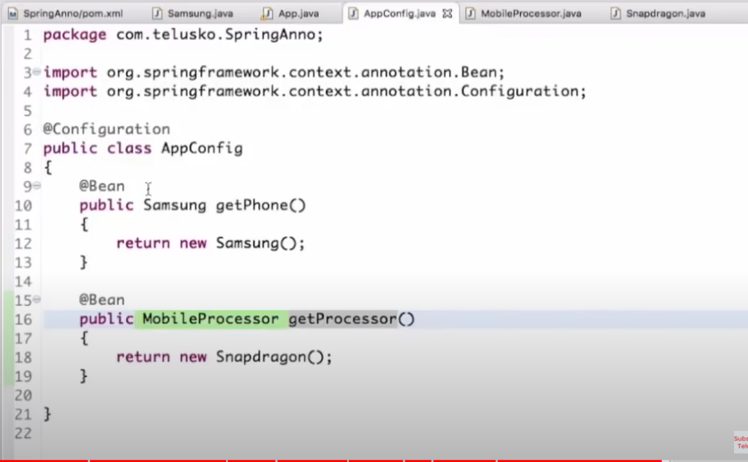

@Bean is java based configuration= method name is not important =>spring just checks for the return type

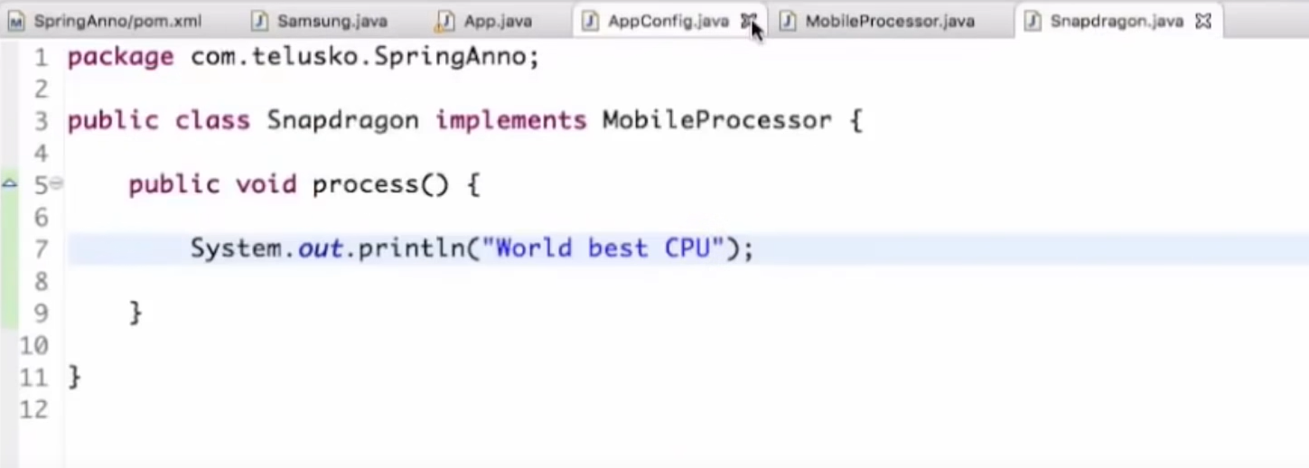

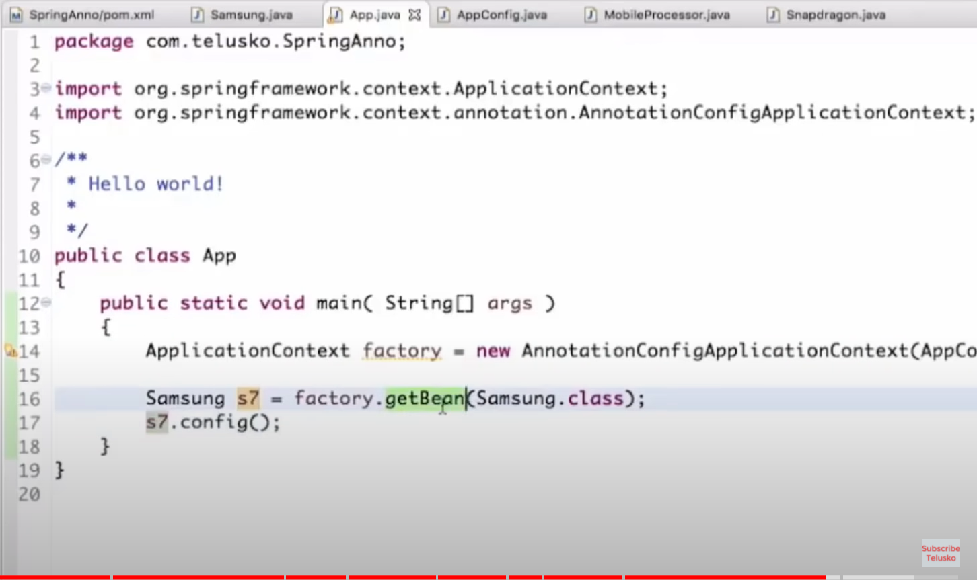

Here we using the ApplicationContext of Annotation one.=>AppConfig.java

We can have multiple Annotation files.

When we run App.java => output is: Octa Core,4gb Ram,12MP camera

World best CPU

Eg2:

What if we comment the @Bean in AppConfig.java.?

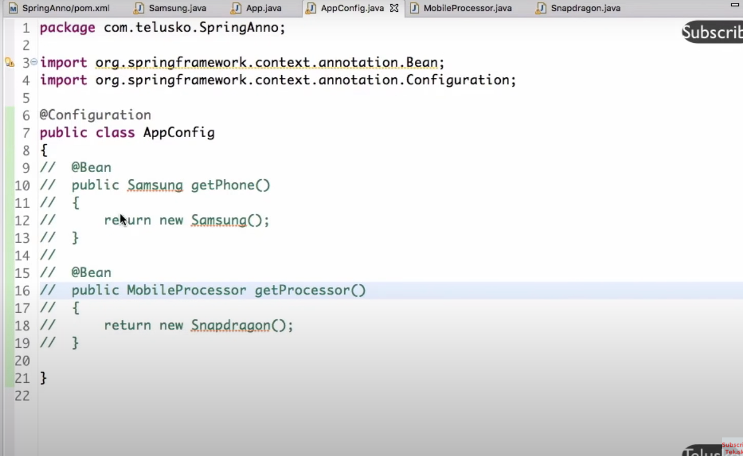

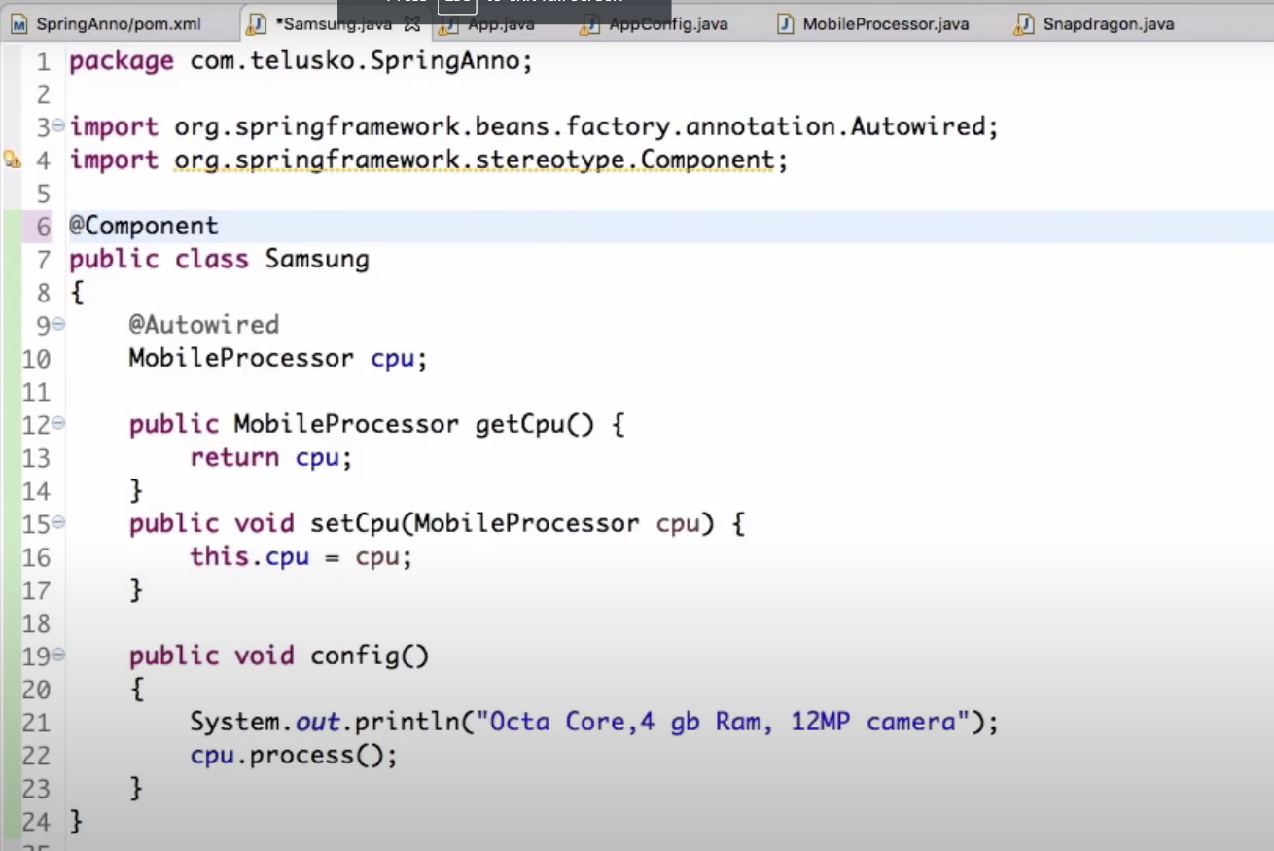

Just mention @Component

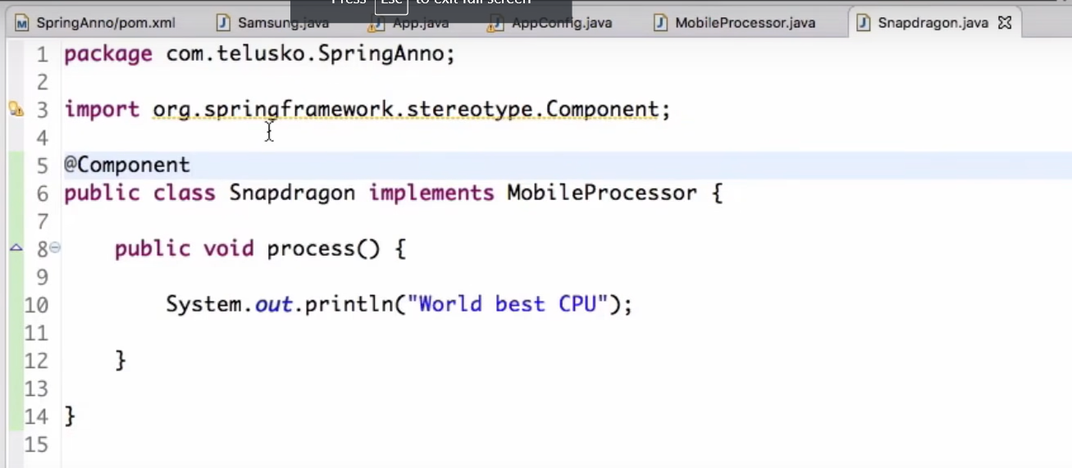

Just mention @Component

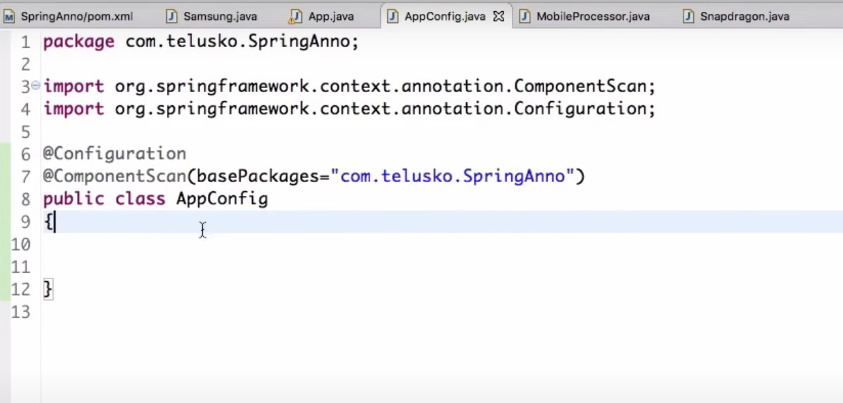

We need to specify the Component packages kidar hai? So mention the package.

Now when we run App.java=>same output as above.

Eg3:

Lets say we have one more implementation of MobileProcessor-MediaTek(snapdragon pehle se tha)

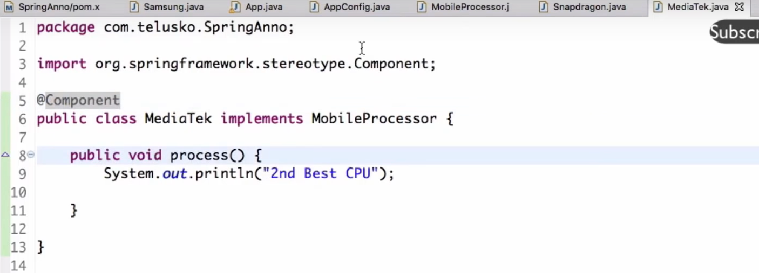

Abhi run kiya then it would throw error no unique been found for MobileProcessor but found 2 bcaz now 2 of the classes are implementing this MobileProcessor = snapdragon and MediaTek



Solution1:

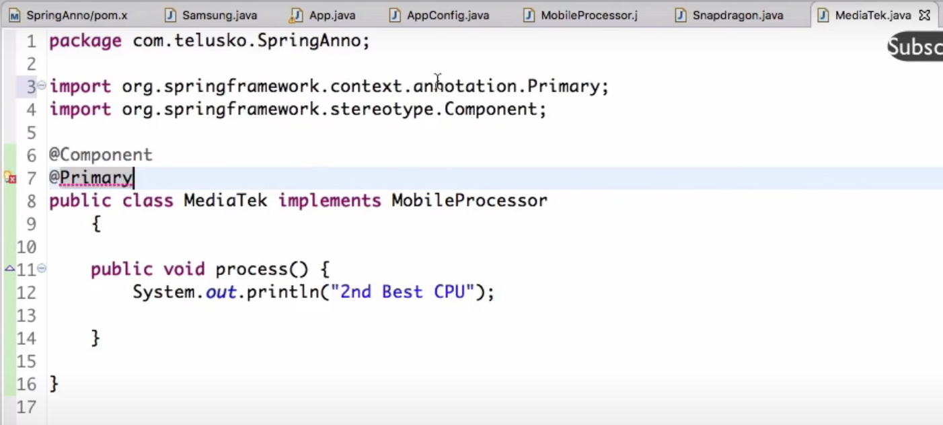

Specify one of them as @Primary so if there any confusion spring would pick the @Primary one

Solution2:

We don’t want to use this @Primary then:

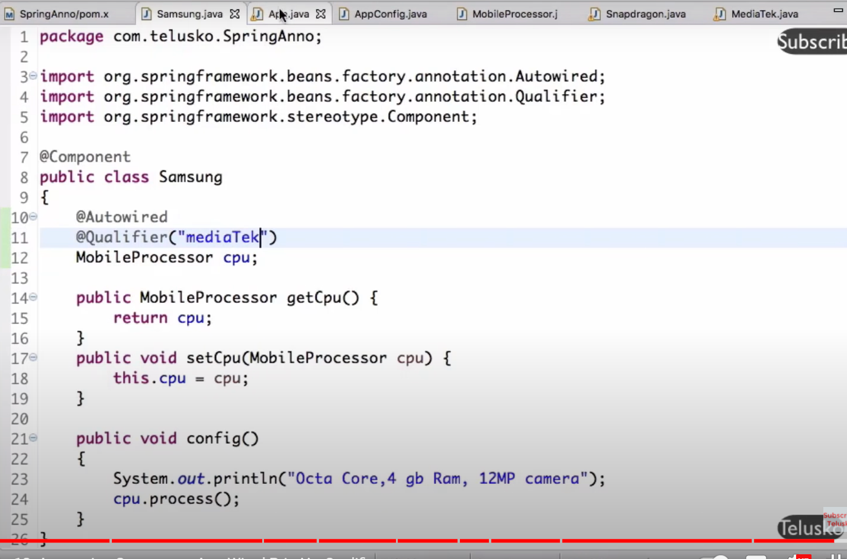

Wherever we are doing @Autowired there we can specify

@Qualifier(“mediaTek”) = who qualified from 2 of the implementing process and we need to call this.